

**APCS Exam 1**

Chapter 1-4

*Time allowed - 40 mins-for CSA2*

**Name**______________________ **Total Marks obtained out of 20** ___________________

**Multiple Choice Questions [2 marks each]**

**1、**Consider the following code segment, which is intended to print the digits of the two-digit int number

num in reverse order. For example, if num has the value 75, the code segment should print 57. Assume that

num has been properly declared and initialized.

/* missing code */

System.out.print(onesDigit);

System.out.print(tensDigit);

Which of the following can be used to replace /* *missing code* */ so that the code segment works as intended?

(A) int onesDigit = num % 10;

int tensDigit = num / 10;

(B) int onesDigit = num / 10;

int tensDigit = num % 10;

(C) int onesDigit = 10 / num;

int tensDigit = 10 % num;

(D) int onesDigit = num % 100;

int tensDigit = num / 100;

(E) int onesDigit = num / 100;

int tensDigit = num % 100;

**2、**Consider the following statement, which assigns a value to b1.

boolean b1 = true && (17 % 3 == 1);

Which of the following assigns the same value to b2 as the value stored in b1 ?

(A) boolean b2 = false || (17 % 3 == 2);

(B) boolean b2 = false && (17 % 3 == 2);

(C) boolean b2 = true || (17 % 3 == 1);

(D) boolean b2 = (true || false) && true;

(E) boolean b2 = (true && false) || true;

**3、**Consider the following code segment.

int a = 1;

String result = "";

while (a < 20)

{

result += a;

a += 5;

}

System.out.println(result);

What, if anything, is printed as a result of executing the code segment?

(A) 21

(B)161116

(C)161161

(D)16111621

(E)Nothing is printing because of an infinite loop.

**4**、Consider the following code segment.

int a = 1;

while (a <= 2)

{

int c = 1;

while (/* missing condition */)

{

System.out.print("*");

c++;

}

a++;

}

The code segment is intended to print "******". Which of the following can be used to replace /* missing condition */ so that the code segment works as intended?

(A) c<=2

(B) c<3

(C) c<=3

(D) c>2

(E) c>=3

**5、**Consider the following code segment.

int j = 1;

while (j <= 5)

{

for (int k = 4; k > 1; k--)

{

System.out.println("ha"); // line 6

}

j++;

}

How many times will the print statement on line 6 execute?

（A）15

（B）16

（C）20

（D）24

（E）25

6、A student has created a Book class. The class contains variables to represent the following.

An int variable called pages to represent the number of pages

A boolean variable called isHardcover to indicate whether or not the book is hardcover

The object story will be declared as type Book.

Which of the following descriptions is accurate?

(A) An instance of the story class is Book.

(B) An instance of the Book object is story.

(C) An attribute of the story object is isHardcover.

(D)An attribute of the pages object is Book.

(E) An attribute of the Book instance is story.

**Free Response Question [8 marks]**

SHOW ALL YOUR WORK. REMEMBER THAT PROGRAM SEGMENTS ARE TO BE WRITTEN IN JAVA.

Assume that the classes listed in the Java Quick Reference have been imported where appropriate.

Unless otherwise noted in the question, assume that parameters in method calls are not null and that methods are called only when their preconditions are satisfied.

In writing solutions for each question, you may use any of the accessible methods that are listed in classes defined in that question. Writing significant amounts of code that can be replaced by a call to one of these methods will not receive full credit.

Palindrome is a word or phrase that is the same read from left to right and right to left. “racecar” is a palindrome. You will complete the *PalindromeTester* class file to test phrases or words that are entered into the program by the user. Use a loop so the user can check several words or phrases at a time. Your program should output the word or phrase and tell the user if it is a palindrome or not. Then, the program will ask if the user wants to check another phase or word. Use a sentinel value for this outer loop.Notice that you should give friendly prompt for users.

**(Hint) You will need two loops. One to see if the use wants to test another phrase and one that loops through the characters of the phrase. Use methods of the String class. The statement you may need:**

**Scanner scan = new Scanner (System.in);//construct an scan object**

**scan.nextLine();//call the nexLine()method to get the input from user**

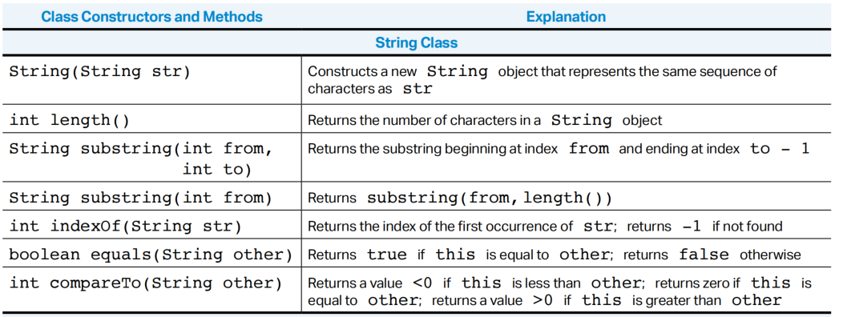

import java.util.Scanner;

public class PalindromeTester

{

// Tests strings to see if they are palindromes.

public static void main (String[] args)

{

}

}